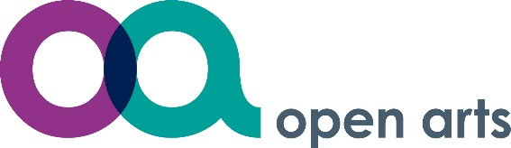 Promoting mental health
and wellbeing through creativity

EPUT’s Open Arts is pleased to offer a 12-week Open Arts programme.

No previous art experience or art skills are necessary; just an interest in art is all that is needed.

The course offers taster sessions in various techniques, in drawing, painting, printmaking, sculpture and craft work. Sample programme on next page.

The course will help improve and maintain mental health and wellbeing, through creative learning, social inclusion, in a safe and supportive environment.

People who have attended previous courses have said:
- “Good fun… Therapeutic! Excellent, loved it, can’t wait until next week… Started off tense but really enjoyed it”
- “Really enjoyed trying out acrylics on canvas.. Absolutely wonderful group to attend! Surprised myself by actually doing well…Very well presented, learning loads”
- A brilliant and relaxing time. Really enjoyed this simple printing technique to achieve fantastic results…Loving it, very friendly and relaxing”
- “I felt I was treated as an artist, not a person with mental health problems”

People who have attended have reported they feel less socially isolated, improvements in
self-identity, confidence and choice and reduction in stress and anxiety.

For further information on the course please email: epunft.open.arts@nhs.net
or call Jo Keay 07580 982 462 or email jo.keay1@nhs.net

Open Arts is NOT FUNDED by the NHS but operates completely on external funding, donations and fundraising by participants, volunteers and local businesses.

Open Arts is managed under EPUT Charity Fund Registered Charity number 1053793

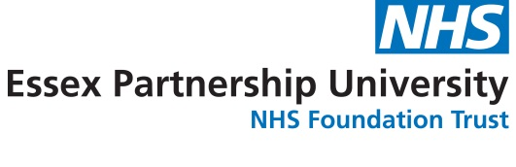
Open Arts sample programme
Week One – Mark making Introductions, exploring drawing materials through timed drawings. Using different mark making techniques with pencils, pastels and charcoals. Bookbinding practical, to make small individual drawing books.

“Good fun… Therapeutic! Excellent, loved it can’t wait until next week… Started off tense but really enjoyed it”

Week Two – Collage Designing and making your paper surfaces using different materials that can then be used to draw onto.

“I enjoyed today and engaging with people as well...loved using all the raw different materials…fantastically relaxing, love collage”

Week Three - Acrylics and mixed media Exploring acrylics and experimenting with different paint techniques on a variety of surfaces.

“Really enjoyed trying out acrylics on canvas.. Absolutely wonderful group to attend! Surprised myself by actually doing well…Very well presented, learning loads”

Week Four – Modroc sculptures Using modroc (plaster bandage) to create functional and sculptural pieces which can be painted during the last week.

“I really enjoyed mod-roc today and it was really therapeutic…. I'm feeling really positive about what I can achieve…Made a sunflower, I did not even think about having a cigarette”

Week Five and Six– Printmaking A chance to develop your ideas through the medium of printmaking - simple printmaking techniques including mono types and simple relief prints “Enjoyed learning new skill”

“A brilliant and relaxing time.. Really enjoyed this simple printing technique to achieve fantastic results…Loving it, very friendly and relaxing”

Week Seven - Clay construction Claywork – Construction. Explore a range of construction techniques using air drying clay

“Enjoyed feeling and using clay-very relaxing…. I really loved playing around with clay”

Week Eight – ModRoc and Clay Sculpture decoration. Decorating modroc sculptures using acrylic paints and other materials.
“It was relaxing and I like painting my work.. Very enjoyable...nice and relaxed”
Week Nine - Inks and Watercolours Learning how to paint a simple watercolour and extending drawing explorations with the addition of colour and ink.
“Really relaxing and learn a lot about watercolours and ink mediums.. Wow, I have a confidence I never had before and it has started a process of believing that I am a somebody- just because I did a piece of ink work that I actually liked and felt good about”
Week Ten, Eleven and Twelve - Individual Arts Development An opportunity for everyone to develop their own theme of work using the skills and materials from the previous sessions, with the support of the Artist.

“I would recommend this art course to everyone as a good form of “mindfulness” so therapeutic”

